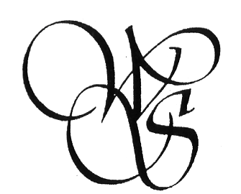
THE DETROIT SOCIETY
OF WOMEN PAINTERS & SCULPTORS

MEMBERSHIP FORM 2018 - 2019

Please complete and return with your membership payment.
Keep the bottom portion for your own records.

NAME__________________________________________________________

ADDRESS_______________________________________________________

CITY________________________________________ ZIP_______________

PHONE________________________________

CELL____________________

EMAIL__________________________________________________________

This membership year is from JUNE 01, 2018 to MAY 31, 2019.
 $35 New     $35 Renewal    $18 Non-MI Resident

I am willing to serve on the following committee:

 Exhibition  Membership  Program  Publicity  Social

Please make check payable to DSWPS and mail to:
Janice Ducsay, Membership Chair
156 Windwood Pointe, St Clair Shores, MI 48080

Check #_________________ Date ________________________
      
---------------------------------------------------------------------------------------------------------

Member_________________________________________________

Dues paid on _______________ Check #___________

Membership for 06/01/2018 – 05/31/2019

